Promise Care Child Development Center’s
December 2024 News!


News from the Director

Wow December is here, and Christmas is right around the corner. I hope everyone has started their shopping already!
We enjoyed our Thanksgiving family party, our gobble gobble song and food …We hope you had fun as well 😊 God bless you 😊

Your child’s Christmas pictures are up and running on the website, Don’t forget to check them out. They turned out so good!

Our weather is beginning to get colder as the seasons change. Please remember to check your child’s cubby to make ‎sure they have an extra set of clothes that are appropriate for the temperature change.

With the change in winter weather come surprises. When Promise Care closes due to inclement weather we will send a detailed message on the app.
You will also find our closing information on channel 6 (CBS) and Channel 8. You also can check the Promise Care website at www.promisecare.org . Promise Care takes into consideration the safety of the children, parents and staff when making closing decisions. I pray for a mild season, but we need to be prepared for the possibility of bad weather.

A reminder to School-Age parents, you need to call Promise Care when your child will not be picked up from school by our vans. Our van drivers have a very tight schedule; spending time waiting for the public school staff to verify that the child was picked up early or did not attend school puts them behind schedule making them late picking up at our other schools.
Also remember:
When Henrico Schools are closed for winter break, PC IS OPEN AT 8.M. for A/S CLASS and please pack lunch for your child. The tuition will be $150 per week.

Promise Care will be closed December 24th , December 25th, December 26^{h}, and Jan 1st for the Christmas Holiday and New year. There is no discounted tuition when Promise Care is closed for holidays and/or weather related closings.

Christmas activities:
Christmas Shirt on 12/06
Christmas Cookies 12/09
Santa’s visit 12/13
Christmas PJ 12/17
Wear Red for our video 12/20
Christmas parties on 12/23 at 3:00 p.m.

For staff Christmas gifts, we have a spread-out sheet for your child’s teachers’ favorite candy, food, drinks, scents and more… I will send out as soon as possible.
Thank you😊

If you are sending someone else to pick up your child, please remember to call the office before 5:30 p.m. to make sure your child has been picked up.

Happy Birthday Jesus!
Merry Christmas to all Promise Care families and staff



Ms. Neven Kalda- Director

Promise Care would like to wish a Happy December Birthday to our following children/staff:

Ms. Grace…. Dec 14th
Abby…A/S………… Dec 3rd
Lavinia …..…PKII….Dec 9th
Amanda….Infants…. Dec 14th
Sophia PKII class…. Dec 20th
Davi A/S …. DEC 9th
Isaac Toddlers…. Dec 28th
Dylan A/S class… Dec 26th

May God continue to bless & keep us
safe this holiday season!
Ms. Neven Kalda-Director

Infant Insights

Merry Christmas! We are extra excited for the families who have a baby celebrating their first Christmas. We are also thrilled that our 2nd Christmas babies can open their own presents.
This December we have a LOT of footprint Art planned.
The themes are snow and Christmas!
We pray everyone has a safe and Happy Holiday!
Love,
Ms. Ms. Carol, Ms. Nadine., Ms. Madison Ms. Raquel and Ms. Neek

Toddler Tidbits
The Toddler room children made a bunch of Thanksgiving art projects. They enjoyed the Thanksgiving parties. They will continue to do more during Christmas and this very special time of the year. We are very excited to be celebrating Christmas and learning more about the reason for the season!
We continue to learn about circles, triangles, and squares, Letters and numbers 1- 10.
Merry Christmas and Happy Holidays!
Ms. Lena and Ms. Tamara

Tales from the Two’s I
I am so excited to celebrate Christmas this year as the Lead teacher in 2’sI. I can’t believe that Christmas is almost here and 2024 is almost over!
The month of December is my favorite month of the year! I’m so excited about all the art projects we will be doing this month and we plan on decorating our class with all Christmas decorations. We will have a Christmas party on December 23rd.
We will continue to learn new letters I-J and new numbers 1-7 during the month of December.
Merry Christmas,
Ms. Rupal

Terrific Two’s II
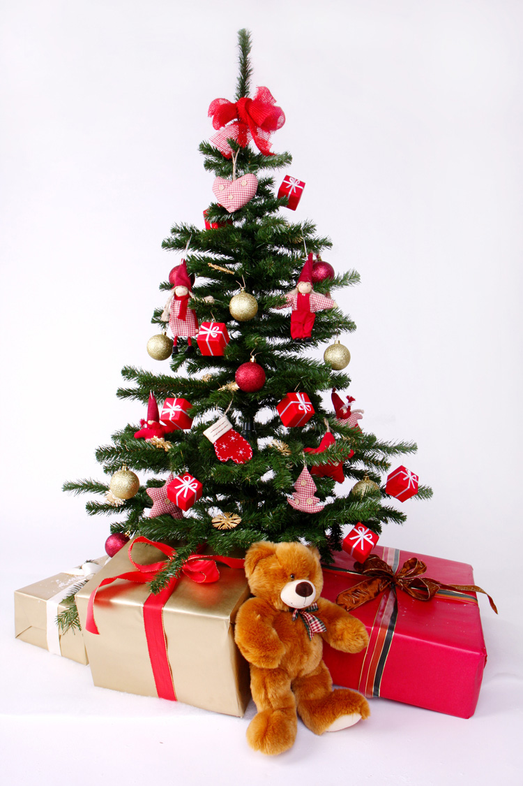
December is the best month of the year because we get to celebrate the greatest birthday of all, the birth of, Jesus Christ, our LORD, and savior! While we are enjoying this wonderful season, we will be reviewing letter “A” to “H” …The Themes for this month are Insects, Indians, Snow, and Christmas. We will read about the 12 spies, Rahab helps two spies, the wall of Jericho, and Deborah helps Barak.
This season we will be celebrating our love for God, and my best friend Jesus. Have a wonderful Christmas Season.
Be Blessed,
Ms. Darqueta and Ms. Eirini

Thrilling Three’s

Can you feel it? It’s in the air!!!
The Best season of all is here …..It’s Christmas. December is very special this month for the Three’s class. This month we are reviewing letters “A” through “H” and numbers “1-7”. New letters this month are I and J and new numbers are 7 and 8. We can’t wait to have fun together!

Merry Christmas and Happy New Year
Ms. Indu, Ms. Amani, and Ms. Ashley


Four Facts

We are excited for December to be here!!
Christmas is here!!!!!
We are having such a great time upstairs in Pre-K I! With the holidays quickly approaching, we are continuing to learn about God’s love for us and appreciating all He has blessed us with. Everyone is doing an amazing job identifying letters as well as writing their names, and we will continue strengthening these skills as the year goes on. I wish everyone a wonderful, blessed and safe Holiday…..
God bless you all,
Ms. Andrea and Ms. Yogita



Four Facts ∏

Season’s Greetings!

Hello Parents, Thank you for all of your help & support to start a strong new school year together!!!
December is another wonderful month we will progress further into our bible stories, alphabet and counting.
I would like to wish you all a Merry Christmas and I pray for all of us to have a wonderful time with our families and friends. Enjoy every moment with your loved ones this season.
God bless,

Ms. Jennifer, Ms. Heather and Ms. Rarah

Awesome Afterschooler

Wow!!! Our awesome 2024 is coming to an end. We had great times, great trips and great fun during this year. The last few weeks we spent a lot of time practicing for our first Thanksgiving play and I think our children did an amazing job 😊 We are learning stories from the bible and practicing good citizens manners.
We are singing our Christmas songs and planning more surprises.
Thank you so much for sharing your all-stars with us. PLAN to be here during winter break for more fun stuff😊
Love,
Ms. Amani

